Hong Kong Exchanges and Clearing Limited and The Stock Exchange of Hong Kong Limited take no responsibility for the contents of this announcement, make no representation as to its accuracy or completeness and expressly disclaim any liability whatsoever for any loss howsoever arising from or in reliance upon the whole or any part of the contents of this announcement.

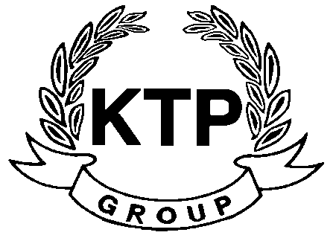
KTP HOLDINGS LIMITED
港台集團有限公司*
(Incorporated in Bermuda with limited liability)
(Stock code: 645)

NOTICE OF BOARD MEETING

The board of directors (the “Board”) of KTP Holdings Limited (the “Company”) hereby announces that a meeting of the Board will be held at Block C, 1st Floor, Wong King Industrial Building, 2-4 Tai Yau Street, Sanpokong at 10:00 a.m. on Wednesday, 24th November 2010 for the purpose of considering and approving the interim results of the Company and its subsidiaries for the six months ended 30th September 2010 and considering the recommendation of an interim dividend, if any.

By Order of the Board
KTP Holdings Limited
Yu Mee See, Maria
Director
Hong Kong, 12th November 2010

As at the date of this announcement, the executive directors of the Company are Mr. Lee Chi Keung, Russell (Chairman), Ms. Yu Mee See, Maria and the independent non-executive directors are Mr. Ng Wai Hung, Mr. Lee Siu Leung and Mr. Yuen Sik Ming.

*For identification purpose only

